**Balochistan:**

Hanna Lake

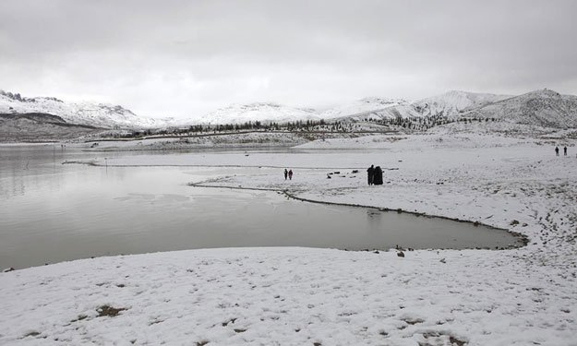

**Hanna Lake** is a lake in Urak Valley near Quetta city in Balochistan Province in southwestern Pakistan. It is surrounded by mountains. Hanna Lake is in the hills close to where the Urak Valley begins 17 kilometres (11 mi) east from Quetta city. The reservoir was constructed in 1894 during the British Colonial era on the land of local tribesmen, and is one of the main attractions in the city and a great historical bridge wall between two mountains the depths like battlements of a fort for storing of water. There is a lakeside restaurant with picnic tables shaded by pine trees at the end of the river where families can enjoy the food and weather on the eastern part the Hayat Durrani Water Sports Academy (HDWSA) the first and only rowing, canoeing, kayaking and sailing training and championships organising centre in Balochistan Province with provision of rough swimming facility. Hanna Lake is one of the most visited and accessible lakes in Balochistan.

Hinglaj Mata

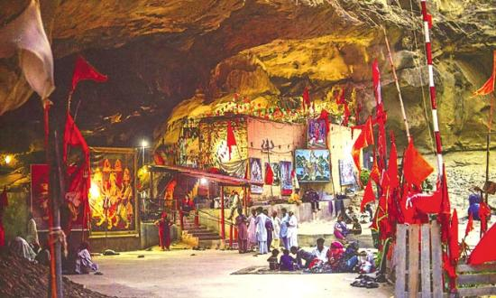

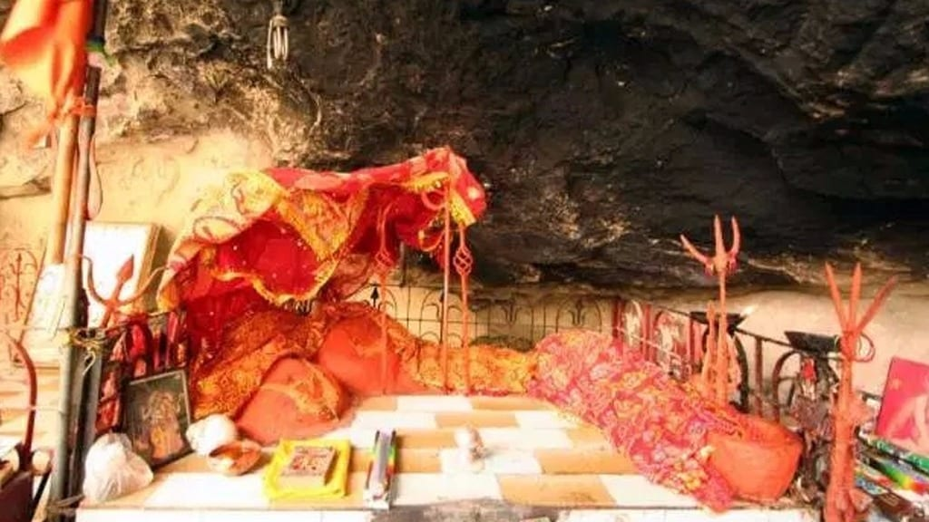

**Hinglaj Mata** also known as **Hinglaj Devi**, **Hingula Devi** and **Nani Mandir**, is a Hindu temple in Hinglaj, a town on the Makran coast in the Lasbela district of Balochistan, Pakistan, and is the middle of the Hingol National Park. It is one of the Shakti Peethas of the Hindu goddess Sati. It is a form of Durga or Devi in a mountain cavern on the banks of the Hingol River. Over the last three decades the place has gained increasing popularity and became a unifying point of reference for Pakistan's many Hindu communities.

Bolan Pass

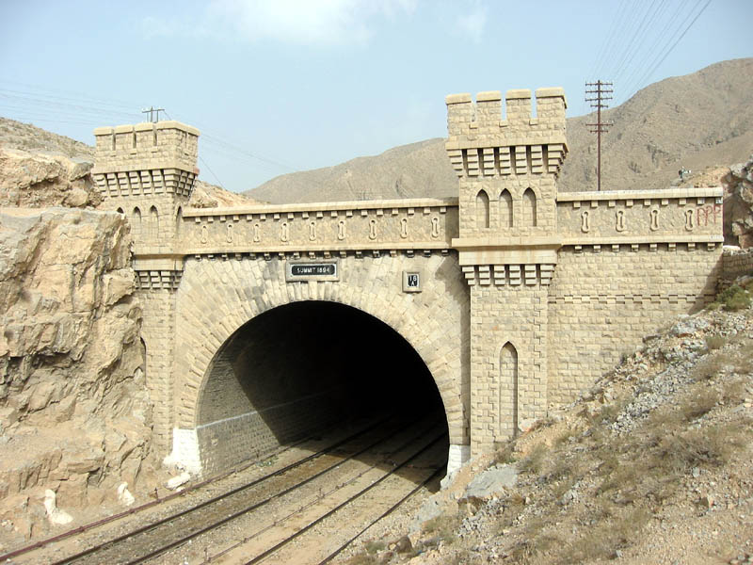

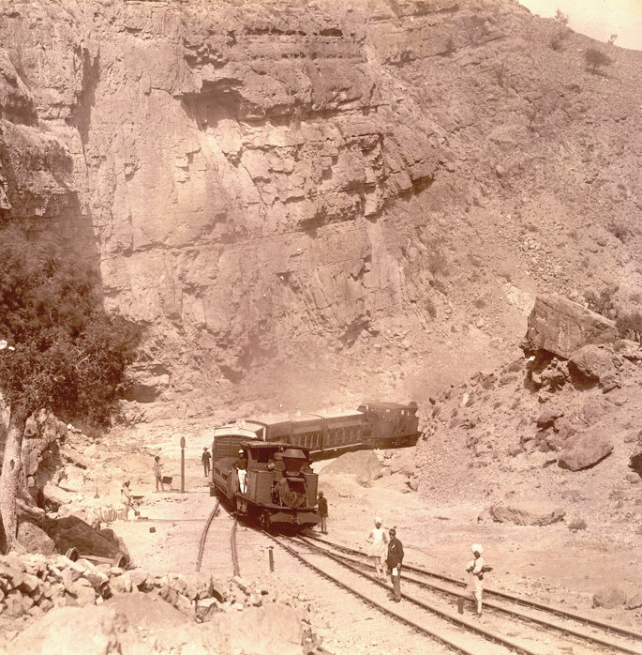

The **Bolān Pass** is a mountain pass through the Toba Kakar Range of Balochistan province in western Pakistan , 120km (75mi) from the Afghanistan border. The pass is an 89km (55mi) stretch of the Bolan river valley from Rindli in the south to Darwāza near Kolpur in the north. It is made up of a number of narrow gorges and stretches. It connects Sibi with Quetta both by road and railway.

Quaid-e-Azam Residency

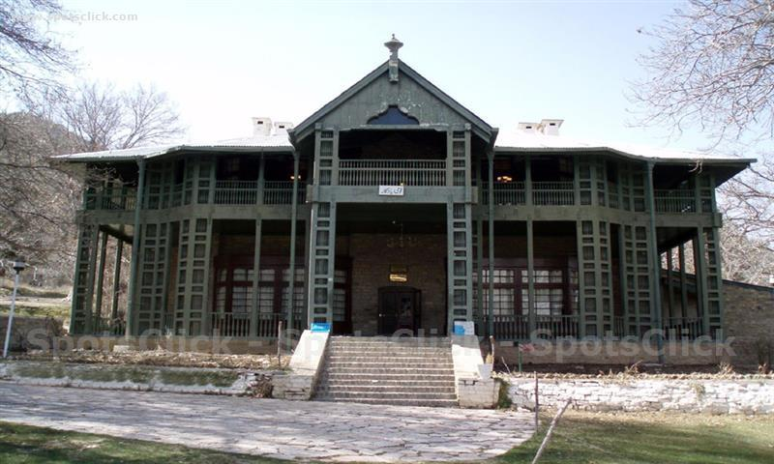

**Quaid-e-Azam Residency** also known as **Ziarat Residency**, is located in Ziarat, Balochistan, Pakistan. It is where Quaid-e-Azam, Muhammad Ali Jinnah spent the last two months and ten days of his life, nursed by A. S. Nathaniel. It is the most famous landmark of the city, constructed in 1892 during the British Raj. The building is a wooden structure, originally designed as a sanatorium before being converted into the summer residence of the agent of the Governor General. It is declared a national monument and heritage site and is of great architectural importance. On 15 June 2013, the Residency was targeted with rockets. The wooden parts of the building were badly affected as a result of the attack. Militants belonging to the Balochistan Liberation Army claimed responsibility. It was badly damaged as a result of the intense attack.[[1]](https://en.wikipedia.org/wiki/Quaid-e-Azam_Residency#cite_note-1) However, the government of Pakistan has vowed to restore the site. The residency was also damaged during the 2008 earthquake. However, despite the wooden structure was badly damaged in the 2013 attack, the concrete structure was standing and the photographs along with the other artifacts were safe and sound.

Koh-e-Chiltan

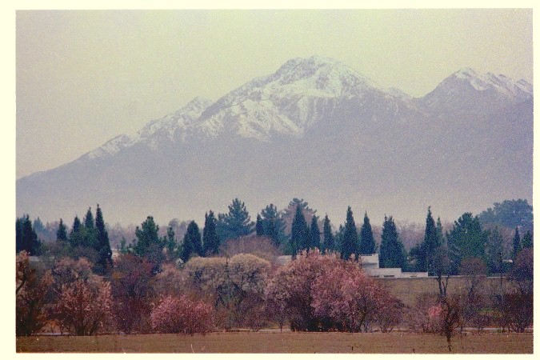

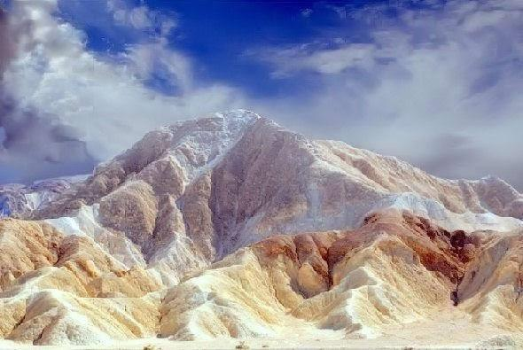

Koh-i-Chiltan is the summit of a steep, rocky mountain called Chiltan or Chehel-Tan (Persian/Balochi: 'Forty Bodies'). 'Lwarrh Saar' is the highest peak of Chiltan mountains range at 3,194 metres (10,479ft), it is the third-highest peak of Quetta after Zarghoon Ghar and Koh-i-Takatu, and fifth-highest peak of Balochistan. There are many juniper trees found in high ranges.

Chotok Waterfalls

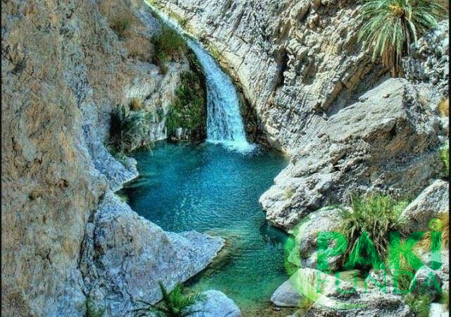

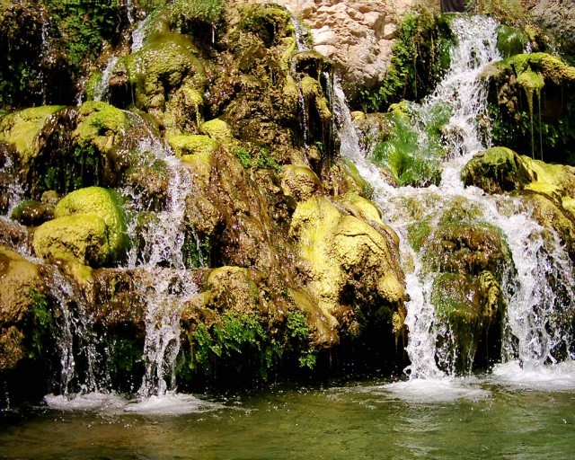

**Chotok Waterfalls** also known as **Moola Chotok Waterfalls** are situated in a village Moola, Khuzdar District of Balochistan the province of Pakistan. Moola is a village and Tehsil of Khuzdar District which is 80 kilometres (50mi) away from Khuzdar. Chotok waterfalls falls between the two hills into a stream of cool water. Khuzdar appears as **Khnenta** in the Zend Avesta and is one of the sixteen beautiful lands created by Ahura Mazda. Khuzdar was the capital of the Brahui kingdom of Makran.